Warren’s Root Collar Weevil (Hylobius warreni) IWW
Low priority
Description
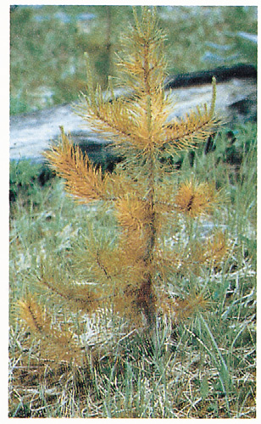
Lodgepole pine is the most common host, followed by interior spruce. Infested plantations display random mortality of single or small groups of trees. Damaged trees exhibit straw-coloured to deep red foliage. Damaged trees are usually easy to push over or have an obvious lean. Larvae are responsible for the majority of the damage. Young trees may be completely girdled at the root collar and die. Older trees are often partially girdled at the root collar, and may be completely girdled around some of the roots; however, no mortality results. Significant damage often occurs when a young stand is located adjacent to an older infested stand, as the flightless adults usually only move a maximum of 13 m per year. Studies indicate that weevil populations increase as duff depth increases.

Extent
This insect is considered a low priority forest health issue in plantations of pine and spruce. Unfortunately, recent experience in other TSAs has indicated that there is an increased risk of in plantations adjacent to MPB killed stands. This is related to the migration of adult weevils from dead stands into adjacent plantations - especially in areas where adjacent mature stands of pine have been dead for 4-5 years. This pest is being monitored at the Regional and District levels in various TSAs. Based on this monitoring, the ranking of Warren root collar weevil may increase in the future. A UNBC research project has been completed in the Lakes TSA. The results indicate that there is a pattern of increasing mortality and that mortality should continue to increase in direct correlation to MPB-killed stands

Data

Tactics
- Incidence levels should continue to be monitored and their priority reassessed at the annual review stage.
- The use of mixed species in planting will reduce the possibility of damage from this insect.
In the Lakes and Morice TSAs where Warren root collar weevil levels have been more severe tactics to consider in high hazard areas (especially SBSmc subzones in areas where adjacent standing MPB-killed trees have been dead for 5 years):
- Include a general assessment of root collar weevils within the area to be harvested and the adjacent mature pine stands for an indication of weevil populations.
- Delay planting by 2-3 years. Seedlings will not be attacked until they have a root collar of at least 2 cm.
- Plant a less susceptible tree species along cutblock edges. Host species are mainly Lodgepole pine, but also Engelmann, white, and hybrid spruce.
- Reduce duff layers: this includes treatments such as broadcast burning, scarification mounding and disc-trenching.
- Increase planting density: recommend higher than 1600 sph in anticipation of mortality.
- Delay spacing until stand is at least 20 years old.
- Produce hazard and risk mapping.

Warren Root Collar Weevil Stand Establishment Decision Aid
Authors: Larry McCulloch,Brian Aukema,Ken White,Matthew Klingenberg, 2009
http://www.forest-insects.umn.edu/pdfs/2009/09McCullochBCJEM10.pdf

